SPONSORSHIPS
Good planning doesn’t just happen... 2020
Annual Conference Information
Mission
Our vision is of strong and livable communities guided by informed citizens. Our mission is to help shape a vibrant Washington through effective and informed community planning.
We do this by providing an inclusive forum for sharing problems and solutions, developing planning knowledge and putting this knowledge into the hands of the public and their elected officials. Our goals are to provide education, develop a sustainable infrastructure that will build organizational capacity and grow awareness of the purpose and value of PAW.
Topic: Sound Planning, Strong Economies

April 22-24, 2020
Campbell’s Resort on Lake Chelan
Last year more than 100 people attended the Planning Association of Washington’s premier event. This year’s annual conference will
focus on Reconomics, the economic impact of outdoor recreation and provide a Planners’ Skills Camp. The event offers continuing education credits for accredited planners and Washington attorneys.
Sponsors enjoy exposure to more than 26 municipalities from across Washington State including counties and cities of various sizes.
Additionally, sponsoring the Planning Association of Washington ensures communities, elected officials, and planners have access to
the educational resources they need to keep Washington healthy and
thriving.

Additional Sponsorship Opportunities

Coffee Break Sponsor
The best part of every conference? Networking at the coffee breaks. Sponsor a coffee or snack break with signage at the station and a special thank you from the podium.
Price depends on sponsor’s selection of goodies!

Speaker Sponsor
Providing the best education to attendees is important to us. Help sponsor our keynote speaker, panel speakers, and guest speakers.
Price and benefits depend on sponsor’s selection of sponsee!

Find more information at:

www.planningassociationofwa.org or contact fawn@aminc.org

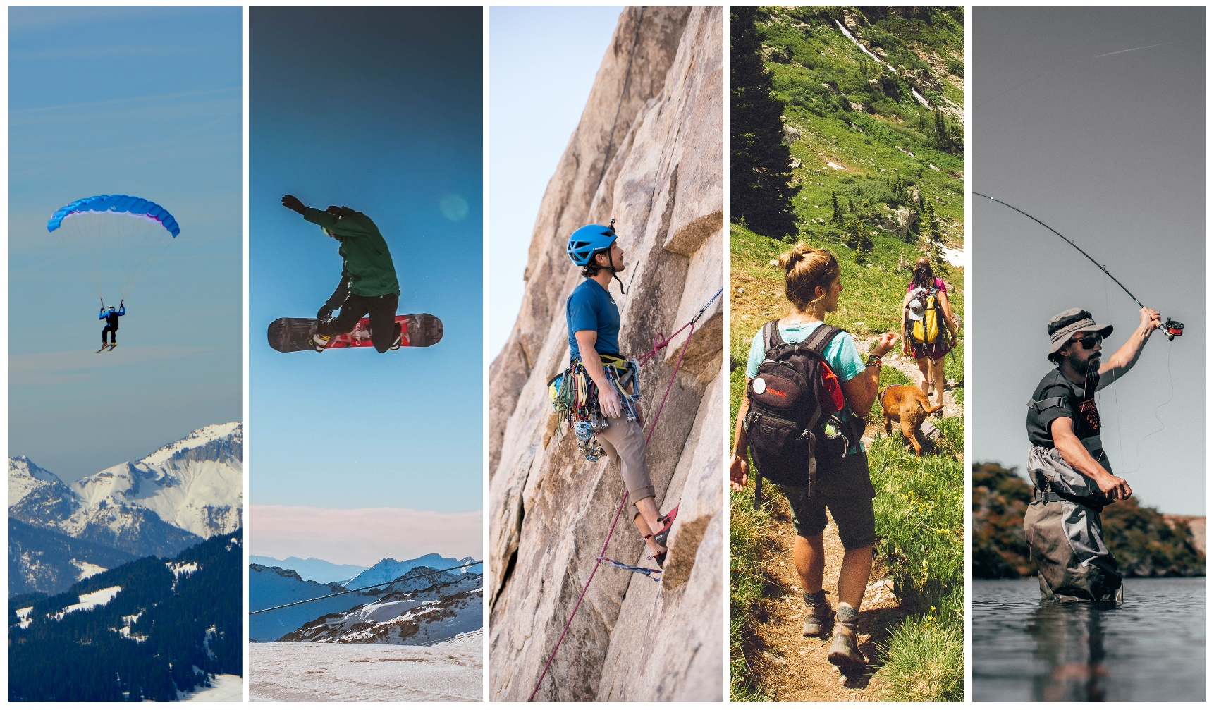

 | Parachuter | Snowboarder | Rock Climber | Hiker | Angler
 | $2,500 | $1,500 | $750 | $250 | $100
Heartfelt Thank You Note from PAW | • | • | • | • | •
Name in Event Program | • | • | • | • | •
Listing in PAW E-News (four published annually) | • | • | • | •
Logo in Event Program | • | • | • | •
Logo in Event Slideshow | • | • | • | •
Listing on PAW Website | • | • | •
Information Table During Event | • | • | •
Information in Event Welcome Packets | • | • | •
Logo and Post on PAW Facebook Page | • | •
Exclusive Event Slideshow | • | •
Conference Registration (# of attendees) | •  (2) | •  (1)
Information on Tables During Plenary Session | •
Naming Rights to a Conference Plenary Session or Session Intro | •

Please complete the information below to register as a sponsor. Your print ready logo should be emailed to fawn@aminc.org.

Business/Individual:

Contact Name:

Email: Phone:

Sponsorship Level: (select one)
 Parachuter  Snowboarder  Rock Climber  Hiker  Angler  Other

Credit Card Number:

Card Type:  MasterCard  Visa Exp. Date: CV Code: Names of registrant(s) included with sponsorship level:

Name: Contact:

Name: Contact:

Please send me a conference registration form  Please invoice me

